0808

USER MANUAL

Project Requirement:

1. Online Search
2. Data Storage
3. Offline Queries
4. Persistence of Data
5. Processing Individual Pages
6. Input/output from CLI
7. GUI
8. Documentaiton
9. Transaction Log
10. Code Length
11. User Registration
12. Innovation #1: Email Reporting
13. Innovation #2: Advance Search & Displaying Item Image

**INTERNET CONNECTION IS MANDATORY\*\***

1. Make sure all files are in the same directory. This includes the JAVA files, text files, and the .jar files.

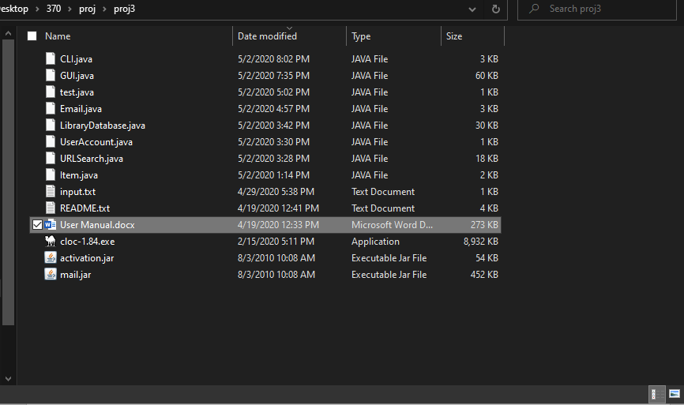

1. Open Command Prompt, the use the ‘cd directory/subdirectory/location’ to change the current directory to the location of the file.

E.g. ‘cd Desktop\370\proj\proj3’

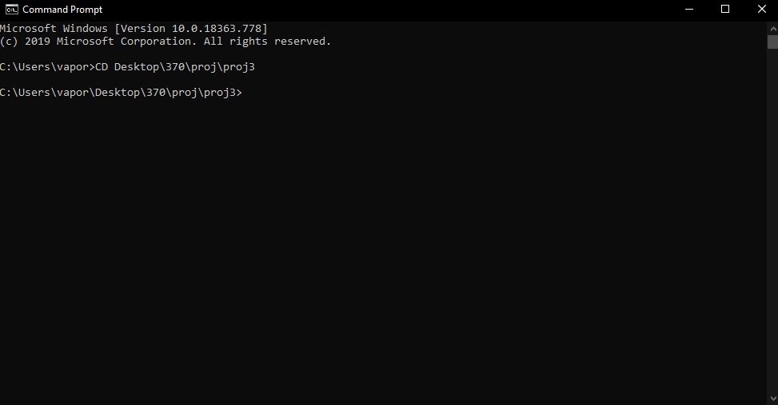

1. Run the command ‘javac -cp “.;mail.jar;activation.jar” Java_file.java’ to create the class files in order to run the program.

Here, we will create the classes files for **GUI**.java and **CLI**.java

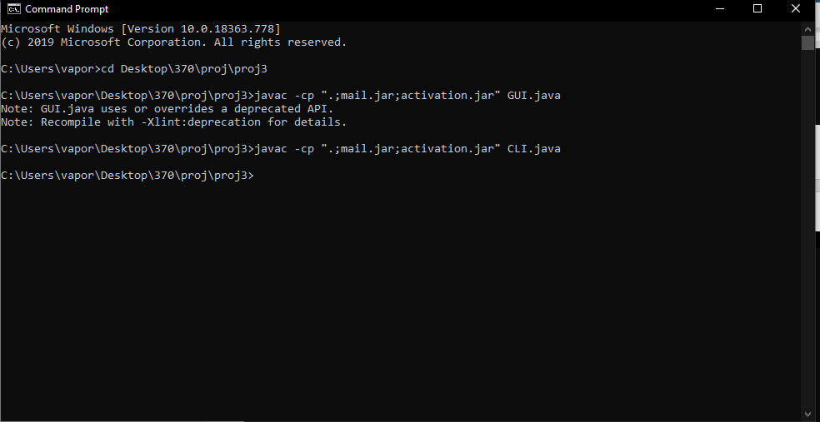

1. Run the command ‘java -cp “.;mail.jar;activation.jar” Java_file’ to run the program.

The screenshot below demonstrates how to run the Command Line Interface of the program .

E.g. : ‘java -cp “.;mail.jar;activation.jar” CLI -i input.txt -o output.txt -p “Kirsten.pevidal08@qmail.cuny.edu”'

Command breakdown:

**‘-cp “.;mail.jar;activation.jar”’**: launch program with the jar files needed for emailing.

**‘-i’** : selects the input file that contains the search terms

**‘-o’** : selects the output file for the printed search results

**‘-p’** : performs an online search query using the search terms

User can optionally receive the output file through an email by specifying an email address encased in quotation marks after the **‘-p’** flag

Command Line Users are all treated as ‘Guest Users’, meaning all search results will NOT be entered to the main Database.

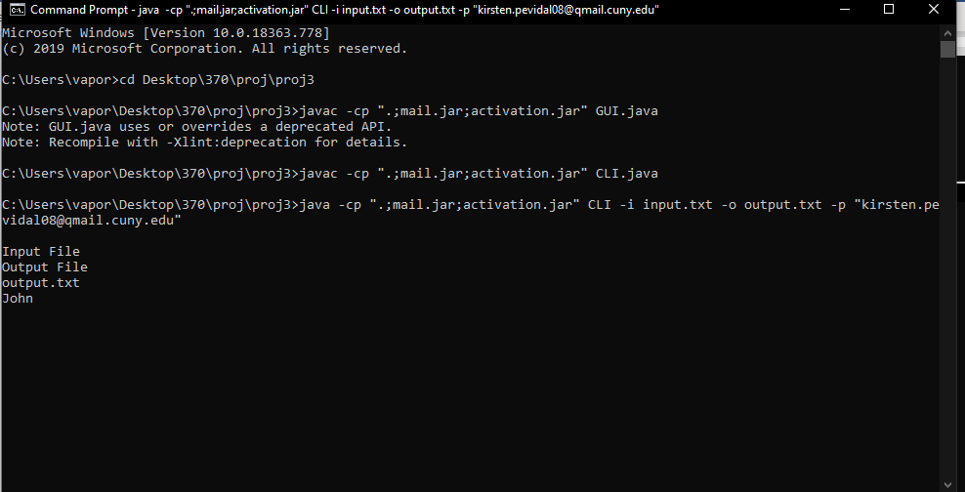



1. **Command Line Interface**

The program will read the input file for the search terms and will conduct and online search query. It will, then , print the result in the command line interface, as well in the output text file.

The sample input text file contains the keywords ‘John’ and ‘Doe’. The program reads it then performs online search for each keywords and prints the results.

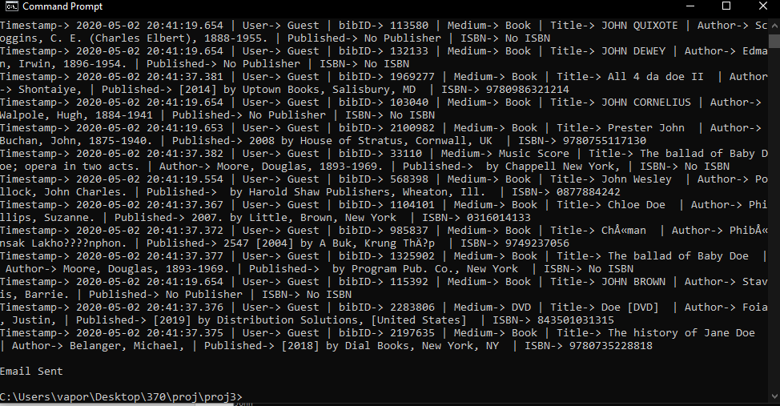

1. **(Innovation #1: Email Reporting)** It will also send a copy of the output file through email if an email address is provided.

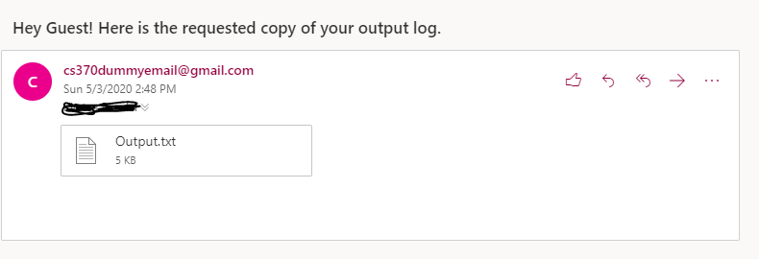

1. The Graphical User Interface of the program can also be launched in the same fashion. Run the command ‘java -cp “.;mail.jar;activation.jar” GUI to run the program.

You will be in ‘Guest Mode’ upon opening the GUI. As a Guest user, you can only access the Online Search Query functionality as well as the Account Login System.

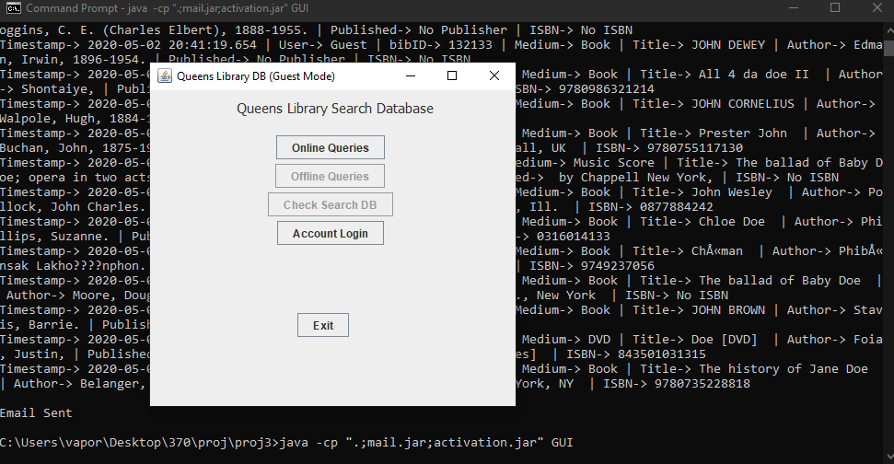

1. **Testing Online Search Query**

Click the ‘Online Queries’ button. It will open a new window where you can enter a search term**. (Innovation #2.1: Advanced Search)** You can also specify the Item medium by selecting the JRadioButton of the desired type of medium.

When ready, press the search button.

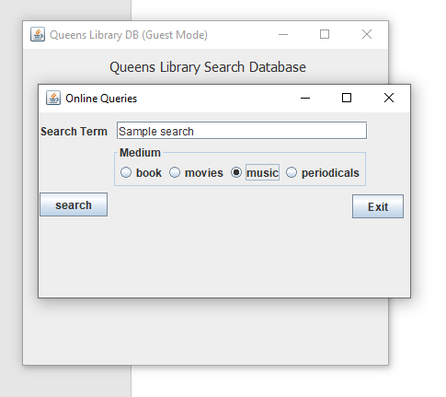

1. The program will display the search result in a JTable. If you are using a Registered User account, you can press the “Add to DB” button which will save the result into your user account database.

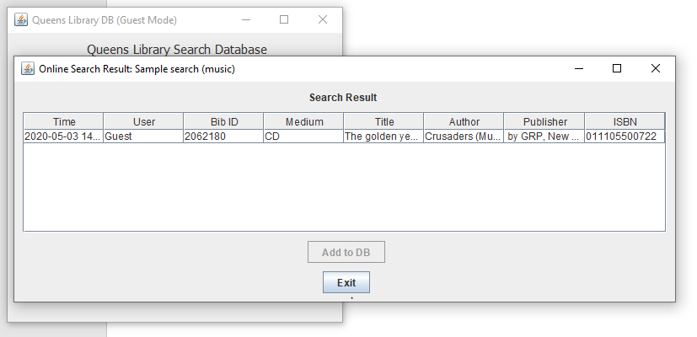

1. **Checking out the Account Login**

Click the ‘Account Login’ button. It will open a new window where you can enter a user name and password to login.

You also have the option to create/register a new account.

If you are currently using a registered User Account, you can press Guest login to revert back to ‘Guest mode’.

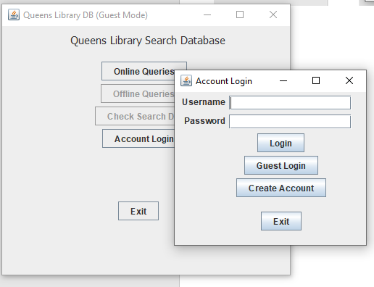

1. **Testing Create Account**

Click the ‘Create Account’. It will open a new window where you can enter a username and password for the new account.

Make sure the ‘password’ and ‘confirm pw’ field matches.

Username must not be blank, contains spaces, or must not be the word ‘admin’ (‘Admin’ is a system-reserved username for admin-access)

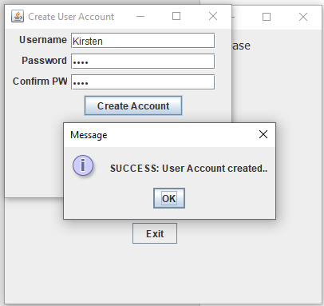

1. **Testing Account Login**

After account creation, you will return to back to the Account login page. Say you manage to successfully create an account, fill up the textboxes with the corresponding information.

If it matches the registered account, it will display a success prompt.

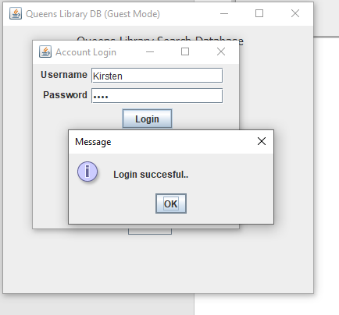

1. After successfully logging in, you can now access the rest of the functionalities.

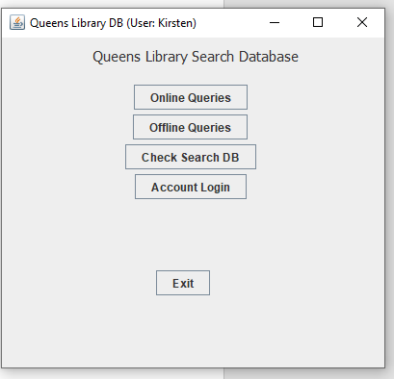

1. **Checking out the User database.**

If you press ‘Check Search DB’, the User Database window will pop-up. Since it is a newly-created User account, its user database is empty.

Once populated, you can start modifying or removing items.

Also, you can transfer search items from Main Database to User database.

Also, **(Innovation #2.2: Displaying Item image)** you can hover to any of the item rows in the User database to display the corresponding image for that item.

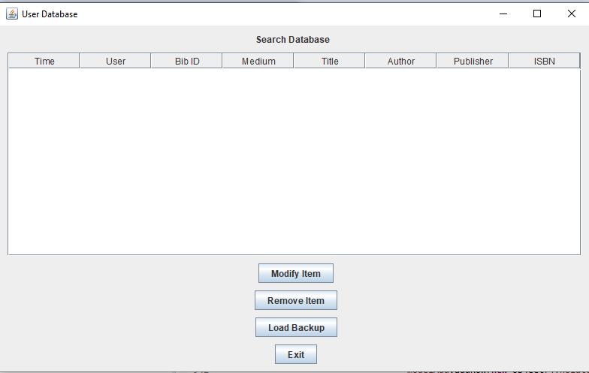

1. **Inserting Search Items to user Database**

To populate the user database, head back to ‘Online Queries’ and perform an online search. Since you are now using a registered account, it will now let you add search result items to your User database.

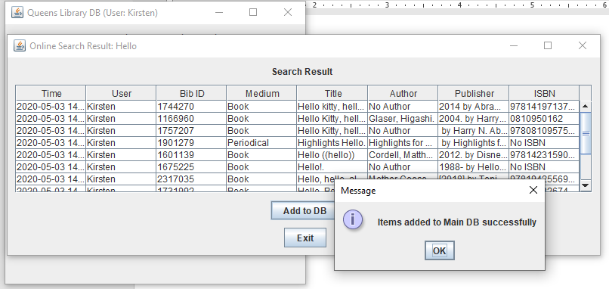

1. Check back your User Database. It will now have the search items you inserted in the previous step.

You can also now hover to item rows to display their corresponding item image.

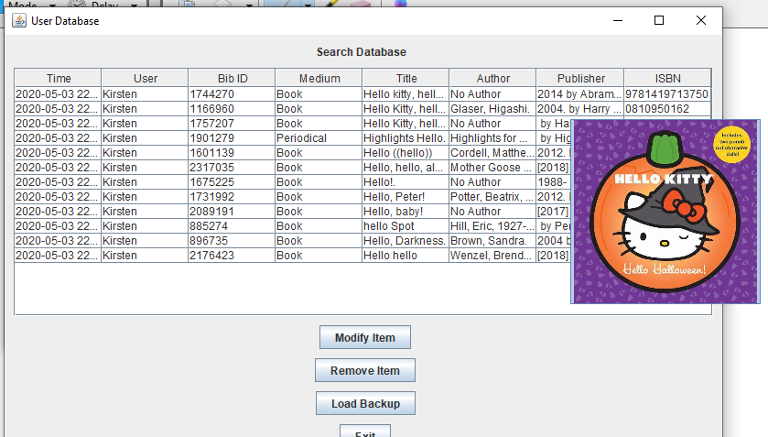

1. **Testing out Offline Queries.**

A user acount can also perform offline searches. Offline searches are conducted by looking into the user database to find a search term.

A user can only search his/her own user database. An admin user can search all user databases since he/she has a copy of all the search items.

To test offline search, head back to the main menu and click ‘Offline Queries’. A window similar to the ones in the online search window will pop-up. You can enter the search term in the search term field.

(Optional) A user can also specify the search date of the item by filling the ‘time’ field.

An accepted format for searching with specified time will be: YYYY-MM-DD.

E.g. 2020-05-02

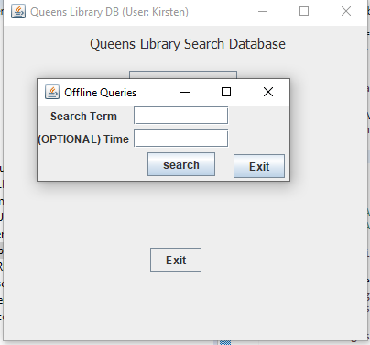

1. Once you fill up the textboxes, press search to display the offline search results. Since offline queries perform searches to items that are stored into user databases, it will also you to perform ‘hover to display item image’.

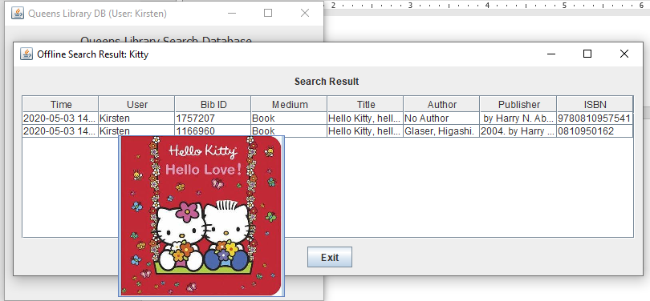

1. After closing the window, a prompt will give you the option to email the current output log you have to a given email address.

Keep in mind, the output log will also have search results from previous queries you conducted after logging in.

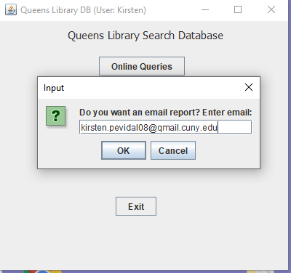



1. If you provided an email and press ‘ok’ during the email report prompt. You can check your email inbox to confirm you receive the output file.

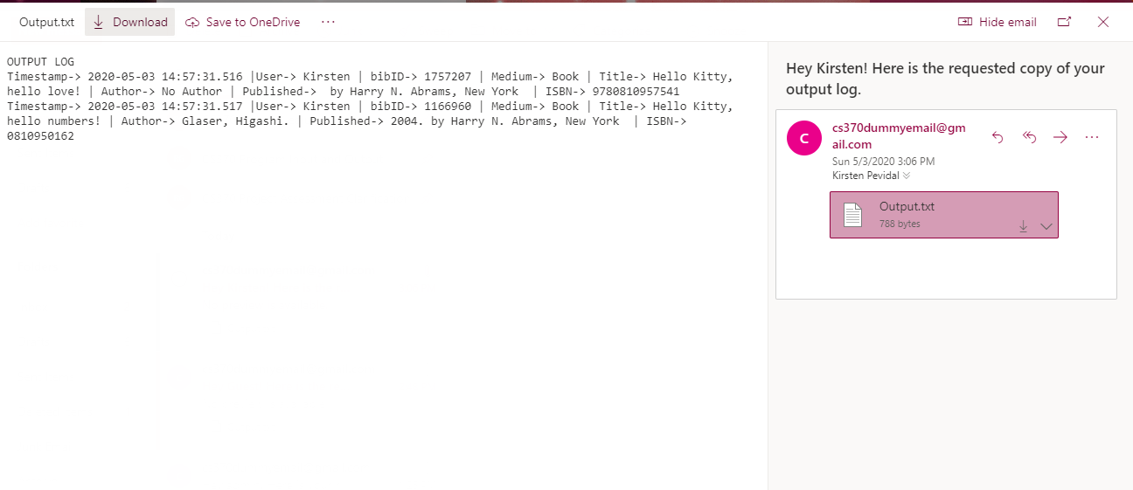



1. **Testing out Admin user Mode**

To test out admin access, head back to Account login. Admin user uses the word ‘admin’ for both the username and the password. After logging in using the said credential. You will now have access to Admin mode.

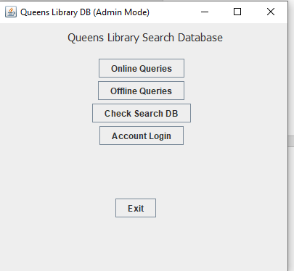

1. If you press ‘Check Search DB’ it will open the Admin (Main) Database. This database contains all search items stored from all the user account database.

User databases are independent from the Main Database. Meaning, if you remove an item from the user database, it will not be removed from the Main database.

Main Database is also used as a backup database.

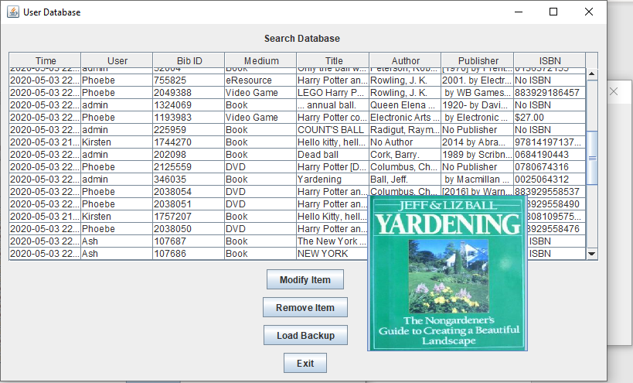

1. **Testing out Item modification**

The User Database window will let user modify items from their database. In order to do this, click ‘Modify Item’

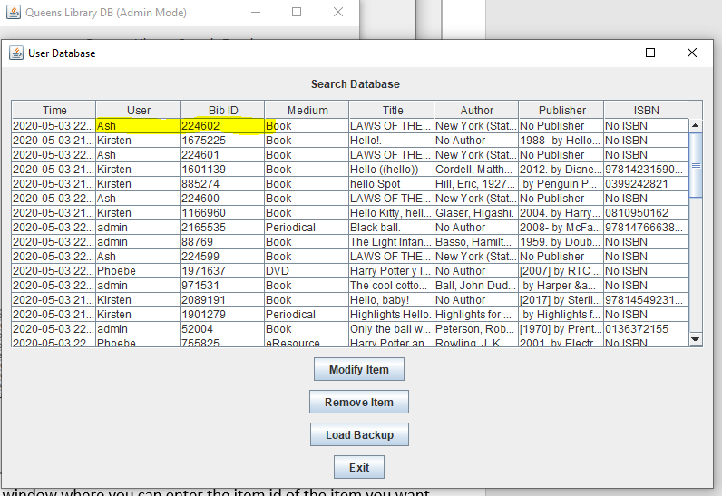

1. It will open a new window where you can enter the item id of the item you want to modified and fill up the rest of the information. If it matches an ID from the user database, it will display a success prompt.

To demonstrate item modification, we will modify the item with ID=224602

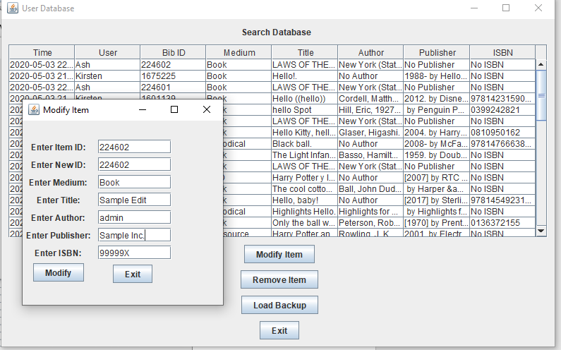

1. After pressing ‘modify’, a prompt will show up. If you successully followed the previous step. It will give you a success prompt and the item table will be updated.

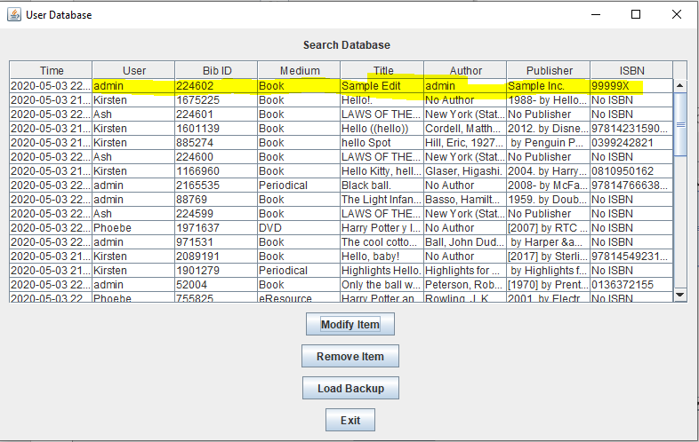

1. **Testing out Item Removal**

The item removal function works similarly. Press the ‘remove item’ button and it will open a window where you can enter the Item ID of the item you want to remove. To demonstrate, we will remove item with id=1461782

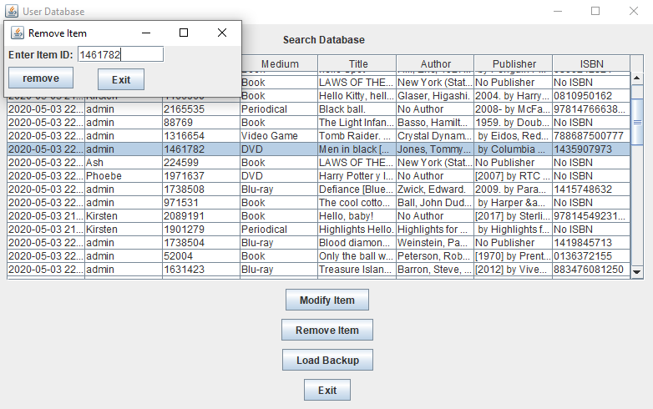

1. Press ‘remove’ button and it will now remove the item. The table will update with the item not being in the table anymore.

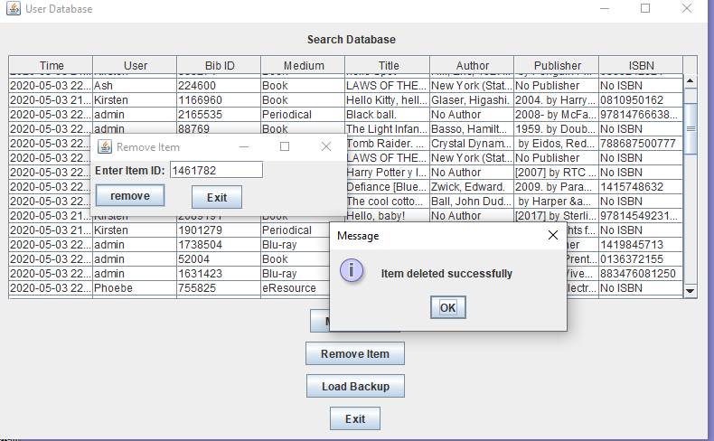

Additionally, Admin User can also request email report. This concludes the primary functions of the program.



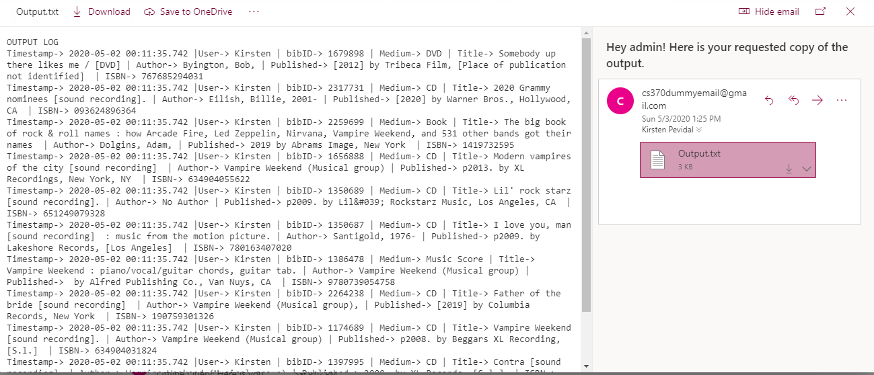



1. **Testing out ‘Load Backup’**

Press ‘Load Backup’. The program will load the Main Database and search for stored items that was previously stored by the User. To demonstrate, we will first empty ‘User: Kirsten’ database.

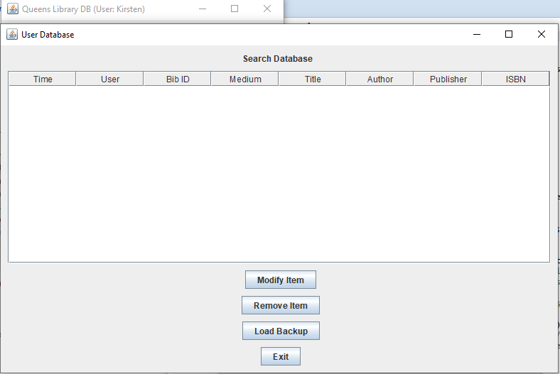

1. Upon pressing ‘Load Backup’, item found in the Main Database that contains ‘Kirsten’ as the User value will be inserted back to the User Database.

